
Class Reg Number

Candidate Name _____________________________

MERIDIAN JUNIOR COLLEGE
JC2 Preliminary Examination
Higher 1

___________________________________________________________________
H1 Chemistry 8872/02

Paper 2 20 September 2010
2 hours
Candidates answer Section A on the Question Paper
Additional Materials: Data Booklet
___________________________________________________________________

READ THIS INSTRUCTIONS FIRST

Write your name, class and register number in the spaces at the top of this page.
This booklet contains Section A and B of your paper.

Section A

Answer all the questions.

Section B

Answer two questions on separate answer paper

Fasten your answers for Section B behind the
given Cover Page on Pg 17.

At the end of the examination, fasten all your work securely together.
The number of marks is given in brackets [ ] at the end of each question or part question.

Examiner’s Use
Section A | Q1 | / 8
Section A | Q2 | / 11
Section A | Q3 | / 6
Section A | Q4 | / 15
Section B | / 40
Total | / 80

This document consists of 16 printed pages.
Section A

Answer all the questions in this section.

1(a) 0.08 mol of solid sulfur is burned in excess oxygen in a calorimeter to form SO₂ gas. The heat produced is used to heat up 815 cm³ of water at 28 °C. Given that 30% of the heat is lost to the surroundings and the enthalpy change of combustion of sulfur, ΔH_{C}^{θ}(S) is -297 kJ mol⁻¹.

Calculate the final temperature reached for the water.
[2]

(b) SO₂ is also an important precursor in making sulfuric acid in which the SO₂ is first converted to sulfur trioxide, SO₃. It is possible to obtain SO₃ by reacting SO₂ with oxygen but this reaction does not occur readily. Instead, the SO₂ is reacted with NO₂ to form SO₃ according to the equation:

SO₂(g) + NO₂(g) → NO(g) + SO₃(g)

Using the given enthalpy change values:

SO₂(g) + ½O₂(g) → SO₃(g) ΔH₁ = -98.9 kJ mol⁻¹
S(s) + O₂(g) → SO₂(g) ΔH₂ = -296.9 kJ mol⁻¹

- Determine the enthalpy change of formation of SO₃.

- Use the Data Booklet and ΔH₁, calculate the bond energy of the S=O bond, giving your answer to one decimal place and state the assumption made in performing the calculation.
[3]

(c) SO₃ can undergo reaction with benzene to form benzenesulfonic acid via the reaction below with concentrated sulfuric acid as the catalyst.
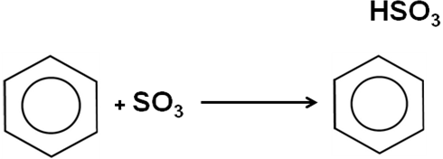
HSO₃

Conc. H₂SO₄

Benezenesulphonic acid is used in the pharmaceutical field to produce a variety of drugs. In an attempt to improve the efficiency of the drug production, the relationship between the rate and the concentration of the reactants is investigated in laboratory. The following two graphs were obtained.
[Benzene]/mol dm⁻³

0
Rate
[SO₃]²/mol² dm⁻⁶

0
Rate

- From the graph, deduce the order of reaction with respect to benzene
and SO₃ and hence write the rate equation for the reaction.

- When the same concentration was used for both benzene and sulfur trioxide, the initial rate of the reaction was measured to be 4.29 x 10⁻⁵ mol dm⁻³ s⁻¹.

Given that the rate constant was 3.54 x 10⁻⁴ mol⁻² dm⁶ s⁻¹, calculate the concentration for benzene used.
[3]

[Total: 8 marks]
2 This question is on the properties of elements and its compounds in Period 3.

Magnesium is an element while silicon dioxide and phosphorus(V) chloride are compounds of their respective elements. The three differ in their chemical structures and bonding but all exist as crystalline solids.

(a) Describe these differences in their structure and bonding.
[3]

(b) Explain why phosphorus(III) chloride exists as a liquid but not phosphorus(V) chloride.
[2]

(c) (i) Describe the reaction when magnesium is burnt in oxygen.

(ii) Indicate whether or not the product formed in (c)(i) reacts with aq NaOH and aq HCl. Include all relevant equations in your answer.
[3]

(d) Briefly describe the action of water on silicon dioxide and phosphorus(V) chloride, writing balanced equations where appropriate.
[2]

(e) With reference to your answer in (c)(ii), suggest why the following reaction is possible.
BeO + 2NaOH → Na₂Be(OH)₄
[1]

[Total: 11 marks]
3(a) Ozone layer depletes at a slow, steady rate per decade since 1969 due to the use of aerosol and refrigerant containing chlorofluorocarbons (CFCs) such as CF₃CCl₃. A ‘healthy’ ozone layer is one which ozone, O₃, is in dynamic equilibrium with oxygen, O₂, molecules in the upper atmosphere:

2O₃ (g)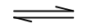3O₂ (g).

The equilibrium concentration of oxygen in the upper atmosphere over America has been approximately constant at 650 DU (Dobson units).

In 1966, a scientist started to measure the concentration of ozone over America for a period of 28 years and realized that a new equilibrium concentration is reached.

[1 Dobson unit = 27 x 10⁹ mol dm⁻³]
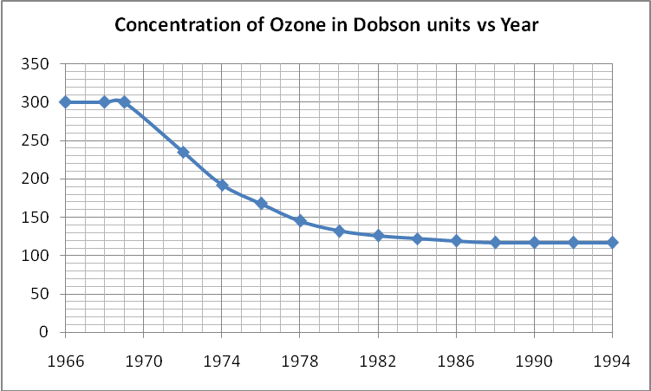

- Write the K_{c} expression for the equilibrium between O₃ and O₂ . Hence
calculate the K_{c} for the reaction in 1966 in Dobson unit.

- From the graph, determine the new equilibrium concentration of ozone after the use of CFCs started.

- Calculate the new K_{c} in 1994 in Dobson unit.

- Suggest a possible reason for the change in value of K_{c} from 1970 to 1994.
[5]

(b) The rapid breaking down of the ozone layer was due to the production of the reactive Cl• radicals from ClO• radicals . One of the intermediate reactions involved is shown in the equation below:

ClO• (g) + O (g) Cl• (g) + O₂ (g)

If this reaction is happening in the lower atmosphere instead of upper atmosphere, will there be any changes in the equilibrium position for the reaction? Explain your answer
[1]

[Total: 6 marks]
4(a) Compound F can be converted to G via a series of reactions.

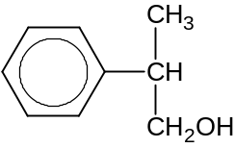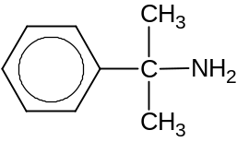
F
G

- Suggest a synthesis route for the conversion of F to G.

H is a positional isomer of G that is also formed from the above process.

- Suggest the percentage of H formed.
[5]

(b) Compound P can be synthesised in the following manner.
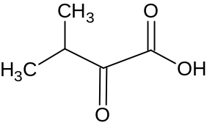
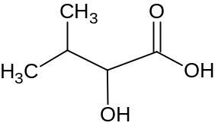
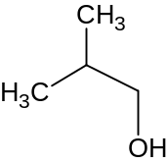
C₄H₈O
Q
HCl (aq), heat
Step 2
Step 4
Step 3
C₅H₁₀
Cold alkaline KMnO₄
N
Step 1

P

Give the structural formula for compounds N and Q. Suggest reagents and conditions for steps 1 to 4:
[6]

(c) Describe a simple chemical test to distinguish between the following pairs of compounds.

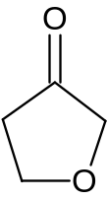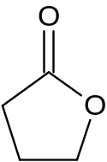(i)

A: and B:

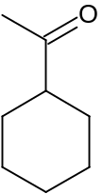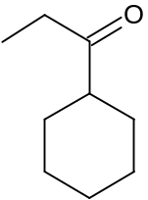(ii)

C: and D:

[4]

[Total: 15 marks]

Section B

Answer two of the three questions in this section on separate answer paper.

5(a) The table below gives the bond energies and boiling points of the various hydrogen halide and halogen bonds.

Bond | Energy/kJ mol⁻¹ | Boiling Point/ºC
H-F | 562 | ?
H-Cl | 431 | -85.1
H-Br | 366 | -66.4
H-I | 299 | -50.8
F-F | 158 | -188.1
Cl- Cl | 244 | -34.0
Br-Br | 193 | 58.8
I- I | 151 | 184.3

- Draw the dot-cross diagrams of HF and F₂ molecules.

- Suggest a reason for the decreasing bond energies from H-F to H-I.

- With reference to the answer you have given in (i), suggest a reason why the F-F bond is weaker than expected.

- Suggest, with reasoning, a value for the boiling point of H-F.
[6]

(b) 0.3 dm³ of HF dissolved in 1 dm³ of water at r.t.p, produces a solution of pH 3.

- Define the term pH.

- Explain whether HF is a weak or strong acid.
[3]

(c) 0.1M NaOH solution is titrated against equal volumes of HCl and HF. The pH values of the solutions were recorded and the following graphs were obtained.

7
pH
Vol of 0.1M NaOH added
Graph 1
Graph 2

- State with explanation which graph represents the titration of HF?

- Explain qualitatively which hydrogen halide is of a higher concentration.

- State with reason, a suitable indicator for the titration of HF.
[5]

(d) Given that the dissociation of CH₃COOH is an endothermic process.

CH₃COOH (aq) CH₃COO⁻ (aq) + H⁺ (aq) ∆H > 0

Give an explanation for the following observations.

- The temperature rise recorded for the neutralization reaction between HCl and NaOH is higher than between CH₃COOH and NaOH.

- When the experiment in (d)(i) is repeated at a higher temperature. The temperature rise recorded for the neutralization reaction between CH₃COOH and NaOH is higher.
[4]

(e) A few drops of sulfuric acid were added to a solution containing equal amounts of CH₃COOH and CH₃COO⁻Na⁺. With the aid of an equation, explain the change in pH of the solution.
[2]

[Total: 20 marks]

6(a) Beams of X²⁺, X³⁺ and S²⁻ ions, travelling at the same speed from different sources are subjected to an electric field as shown in the diagram below.

+++++++

_ _ _ _ _

P1

P2

P3

.

.

.

.

.

P4

P5

- State the positions at which the X²⁺ and X³⁺ and S²⁻ ions will hit the detector.

(ii) Given that the angle of deflection for S²⁻ and X²⁺ ions is 2º and 1.33º respectively and X also contains 25 neutrons.

Find the mass number of X and identify X.
[6]
(b) Sulfur can have molecules in various oxidation states, examples of which are sulfur difluoride, SF₂, and sulfur hexafluoride, SF₆.

- Using the electron pair repulsion theory, predict the shape of SF₄ and SF₆.

- State whether the molecules are polar or non-polar.

- The boiling point of SF₄ is -38ºC and SF₆ is -64ºC. Give an explanation for the difference in boiling points.

- SF₂ reacts readily with F₂ to give SF₄ but OF₂ is unable to react with F₂ to form OF₄. Explain why.
[8]

(c) The rates of chemical reactions determine everything from explosions to how efficiently food is digested. There are four basic factors that can affect the rate of a chemical reaction. They are temperature, concentration/pressure, physical state and catalyst.

- Explain what is meant by the term catalyst.

- By using the concept of activation energy, explain why a catalyst affects the rate of a chemical equation.

(iii) For the reaction of A + B → D, it was discovered that the reaction can proceed via the following mechanism:

Step 1: A + D → C
Step 2: C + B → 2D

State which substances are acting as the intermediate and as the catalyst.

(iv) Given that the graphs representing the catalysed and uncatalysed of a generic reaction are as followed:
[reactant]
[time]
uncatalysed
catalysed

Plot a [A] versus time graph for the reaction A + B →D from (c)(iii).
[6]

[Total: 20 marks]

7(a) On complete combustion, 1 g of an unknown organic compound E produces 2.955 g of CO₂ and 0.671 g of H₂O only.

- Calculate the mass of carbon present in 1 g of E.

- Calculate the mass of hydrogen present in 1 g of E.

- Calculate the mass of oxygen present in 2.955 g of CO₂ and 0.671 g of H₂O.

The mass of oxygen gas used for the complete combustion of E was however, found to be 2.63g.

- Account the difference from your answer in (a)(iii).

- Hence or otherwise determine the molecular formula of E.

- Construct an equation for the complete combustion of E.
[7]

(b) A neutral compound T with molecular formula C₅H₁₀O₃ reacts with phosphorous pentachloride to form compound U, C₅H₉O₂Cl. Compound U gives compound V and CH₃COONa when heated with aqueous sodium hydroxide.

Compound V gives compound W, C₄H₇ON, on heating with ethanolic potassium cyanide.

When W is heated with dilute sulfuric acid, a liquid X, C₄H₈O₃, is obtained. On heating X alone, a sweet smelling liquid Y, C₄H₆O₂, is formed. Oxidation of X gives a solid Z, C₄H₆O₄, which reacts with one mole of sodium carbonate to give one mole of carbon dioxide.

Deduce the structural formula of compounds T, U, V, W, X, Y and Z giving your reasoning.
[13]

[Total: 20 marks]

